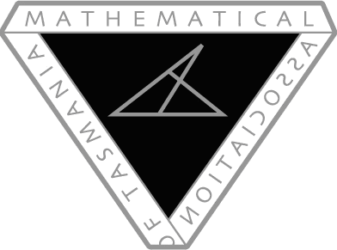
Mathematics Association of Tasmania Conference

May 2017

To infinity and beyond:

Are we there yet?

Keynote speakers – Derek Holton & Helen Chick

Early-career Maths Teachers Day (feat. Derek & Helen): Fri 12th May (9am – 3:30pm)

Conference: Fri 12th (keynote 5:30pm & dinner 7pm) - Sat 13th May (9am – 3:30pm)

Venue: Police Academy, Rokeby (Hobart)

Cost:

$180 Conference + Dinner ($220 non-members; $80 workshop presenters)

$100 Saturday only ($140 non-members)

Additional Cost:

$60 Early-career Teachers Day ($80 non-members)

For more information, please contact Brett Stephenson (BStephenson@gyc.tas.edu.au) and keep an eye on MAT’s website (mat.aamt.edu.au)

